**Lab 5: Using WebHDFS**

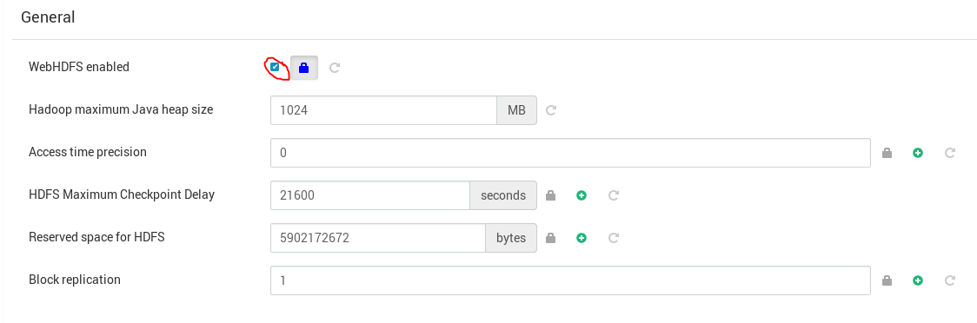

Use the *curl* command with WebHDFS API arguments to list the contents of the HDFS /user/root directory. Use Ambari UI to locate the internal AWS hostname for your NameNode, example would be "ip-172-30-0-184.us-west-2.compute.internal"

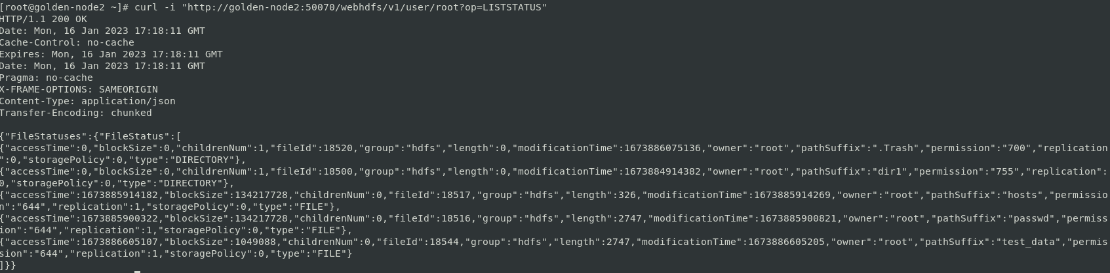

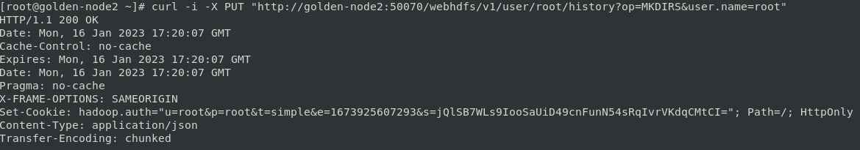

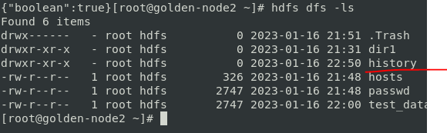

Read the contents of the passwd file using the following *curl* command and WebHDFS API.

**curl -i -L "http://<NameNode Host>:50070/webhdfs/v1/user/root/passwd?op=OPEN"**

